**Phase 5: Apex Programming (Developer)**

**Goal of this Phase**

The goal of Phase 5 was to implement **Apex programming features** in Salesforce to support the Student Management System. This included creating **classes, triggers, SOQL/SOSL queries, collections, asynchronous processing, exception handling, and test classes** to ensure the application is efficient, scalable, and reliable.

**1. Classes & Objects**

* Created **StudentService** Apex class to handle business logic.
* 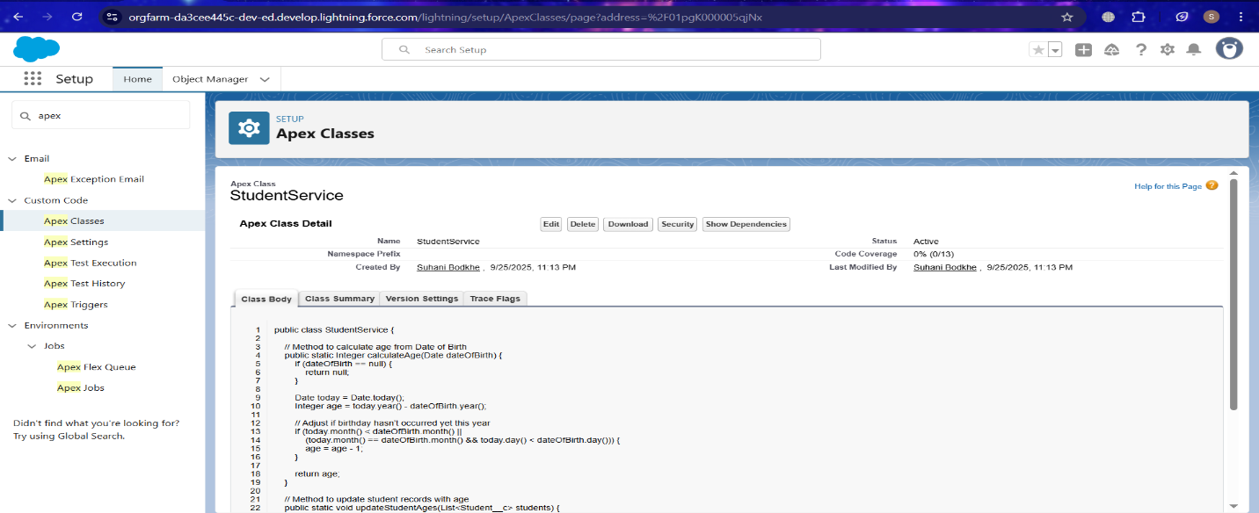Added methods for calculating student age based on Date of Birth and updating records.

**2. Apex Triggers (Before/After Insert/Update/Delete)**

* Implemented a **StudentTrigger** to:
  + Calculate Age before insert/update when Date of Birth is set.
  + Prevent invalid updates using before update triggers.

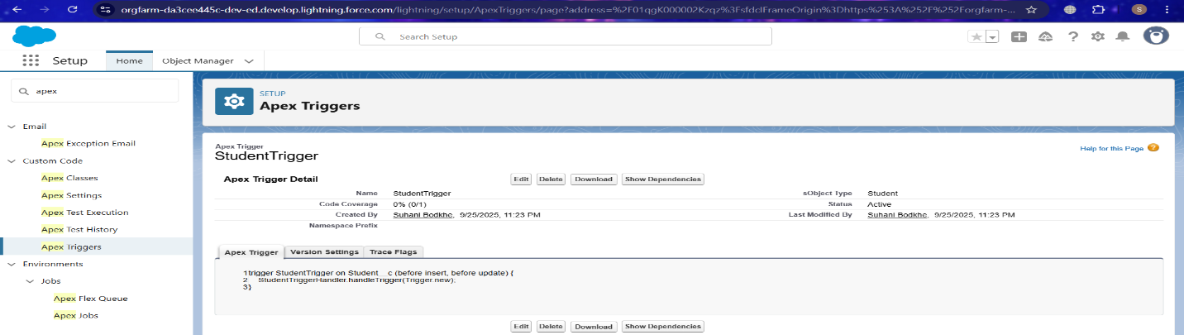

**3. Trigger Design Pattern**

* Applied **Handler Class Pattern**:
  + Trigger delegates logic to StudentTriggerHandler class.

Ensures clean separation of logic, reusable code, and easier maintenance

**4. SOQL & SOSL**

* Used **SOQL queries** to fetch Student records with fields like Id, Date_of_Birth__c, and Age__c.
* Demonstrated **SOSL** for searching students by name across multiple fields.

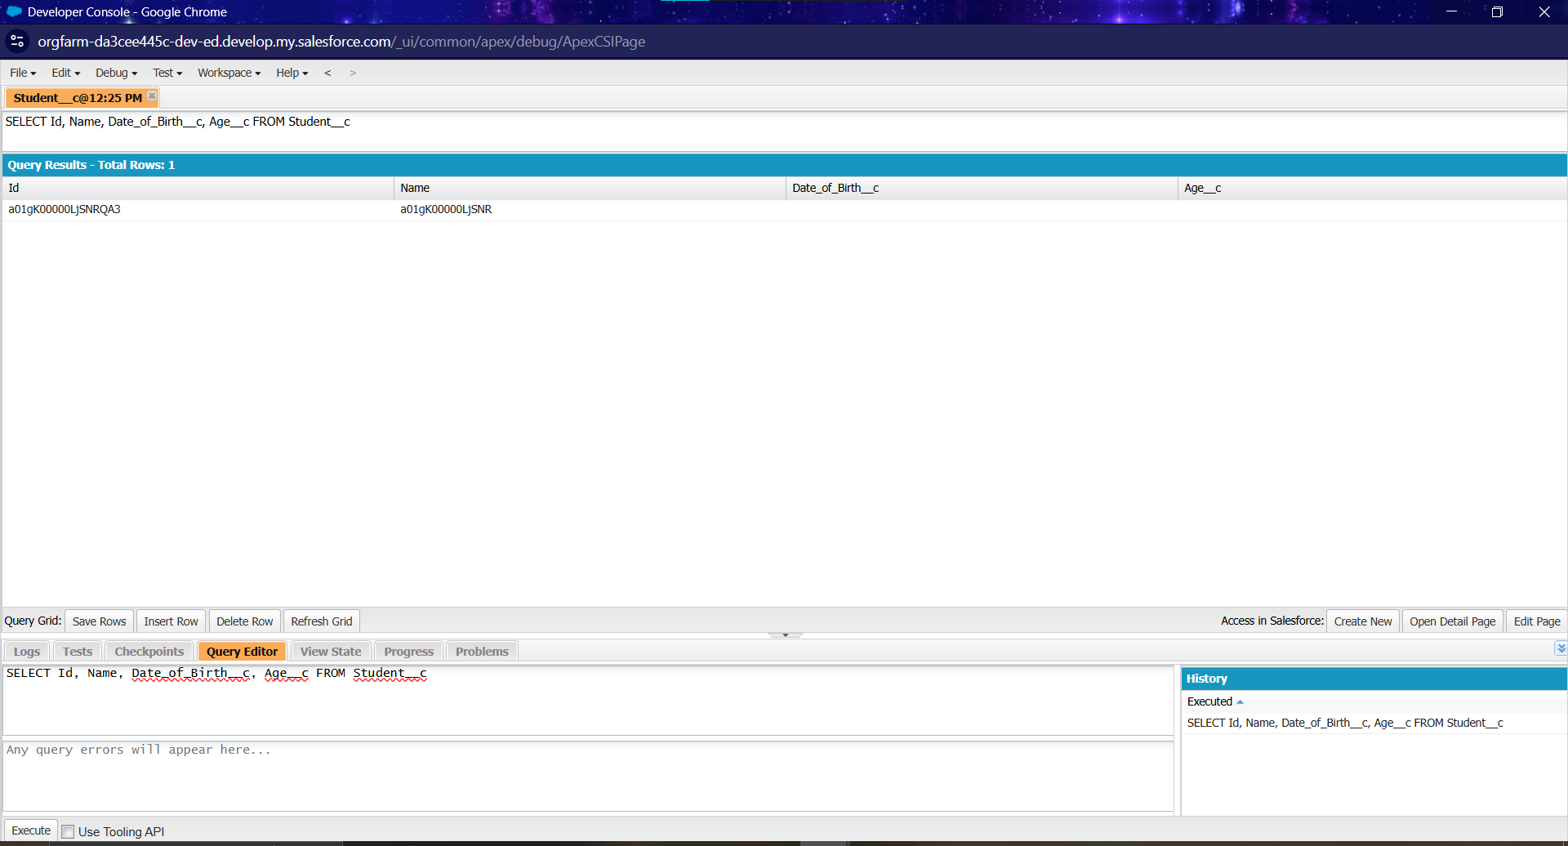

**5. Collections**

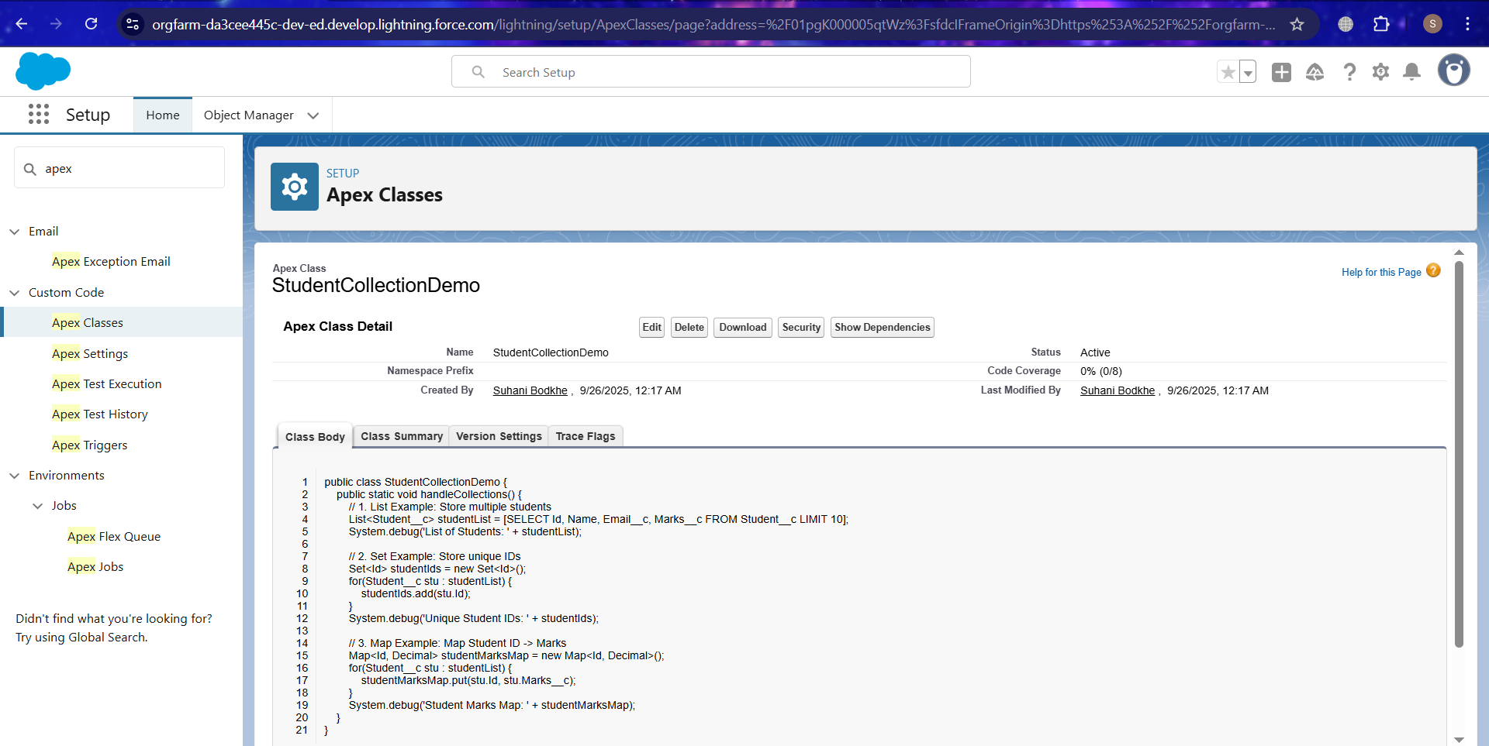  
**5) Test Classes**

* **Use:** Verify that Apex code works correctly and is deployable.
* **Setup:** Setup → Apex Classes → New → Create test methods → Save → Run in Apex Test Execution

